ASSIGNMENT-4

|  |  |
| --- | --- |
| **Assignment Date** | 01 November 2022 |
| **Team ID** | PNT2022TMID36906 |
| **Maximum Marks** | 2 Marks |

# Question 1:

Pull an Image from docker hub and run it in docker playground.

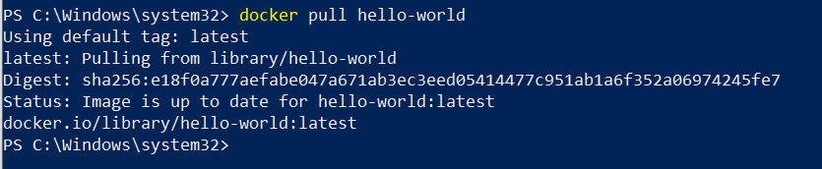

# Question 2:

Create a docker file for the job portal application and deploy it in Docker Desktop Application

FROM helloworld:latest WORKDIR ~/Desktop/ ADD . helloworld/

WORKDIR ~/Desktop/htmlfile RUN pip install -r requirements RUN chmod +x app.sh

CMD ["/bi n/sh","app.sh"]

# Question 3:

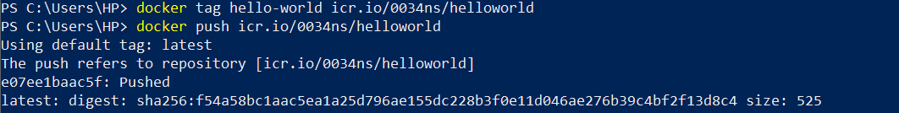Create an IBM container registry and deploy helloworld app or Job portal app.

# Question 4:

Create a Kubernetes cluster in IBM cloud and deploy helloworld image or job portal image and also expose the same app to run in node port.

